

**ASSIGNMENT 5**

[Design of a combinational logic circuit for **3-BIT COMPARATOR** using 2 input NAND GATES]



**NAME: ROHIT SADHU**

**ROLL NO.: 002010501074**



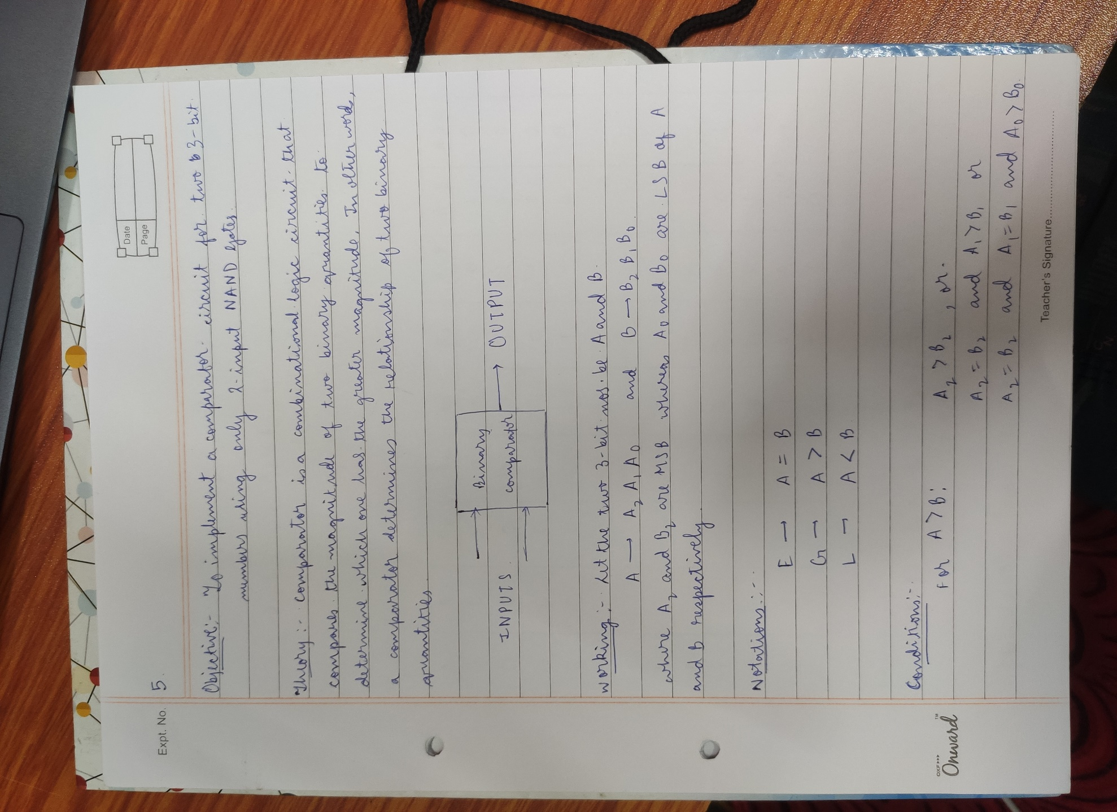

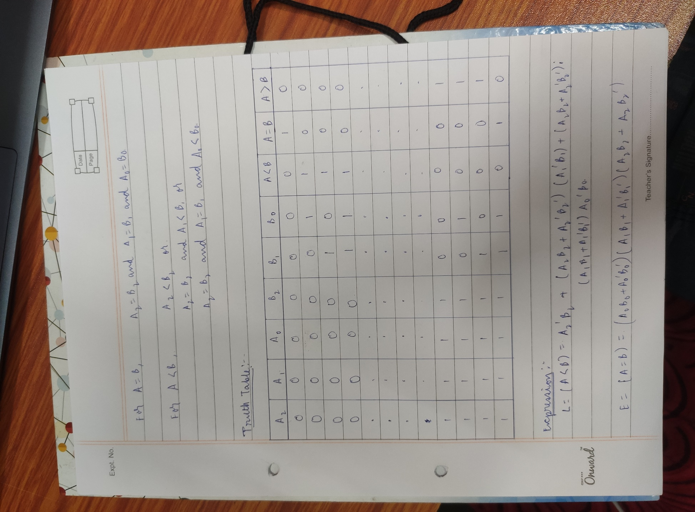

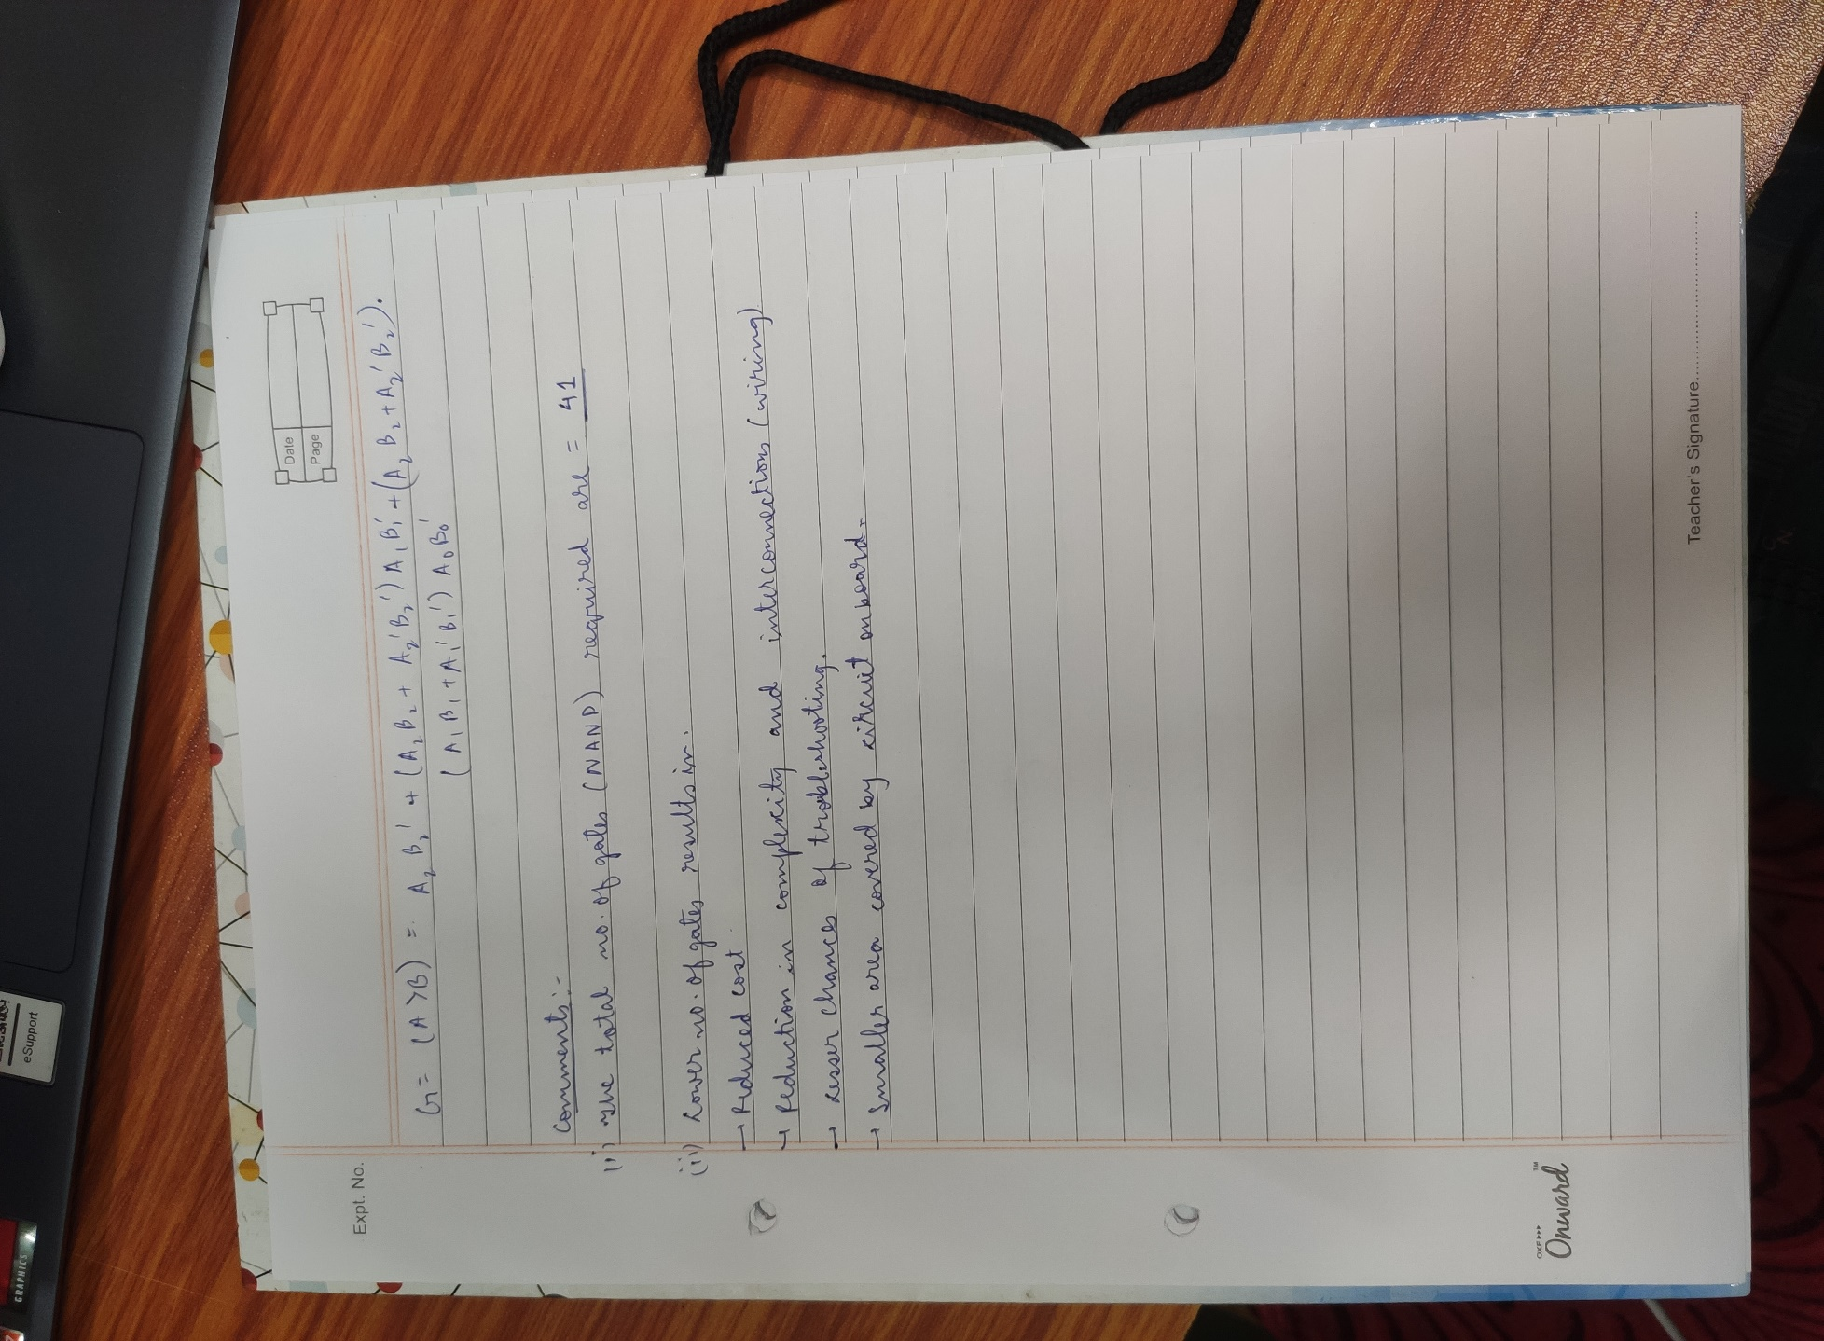

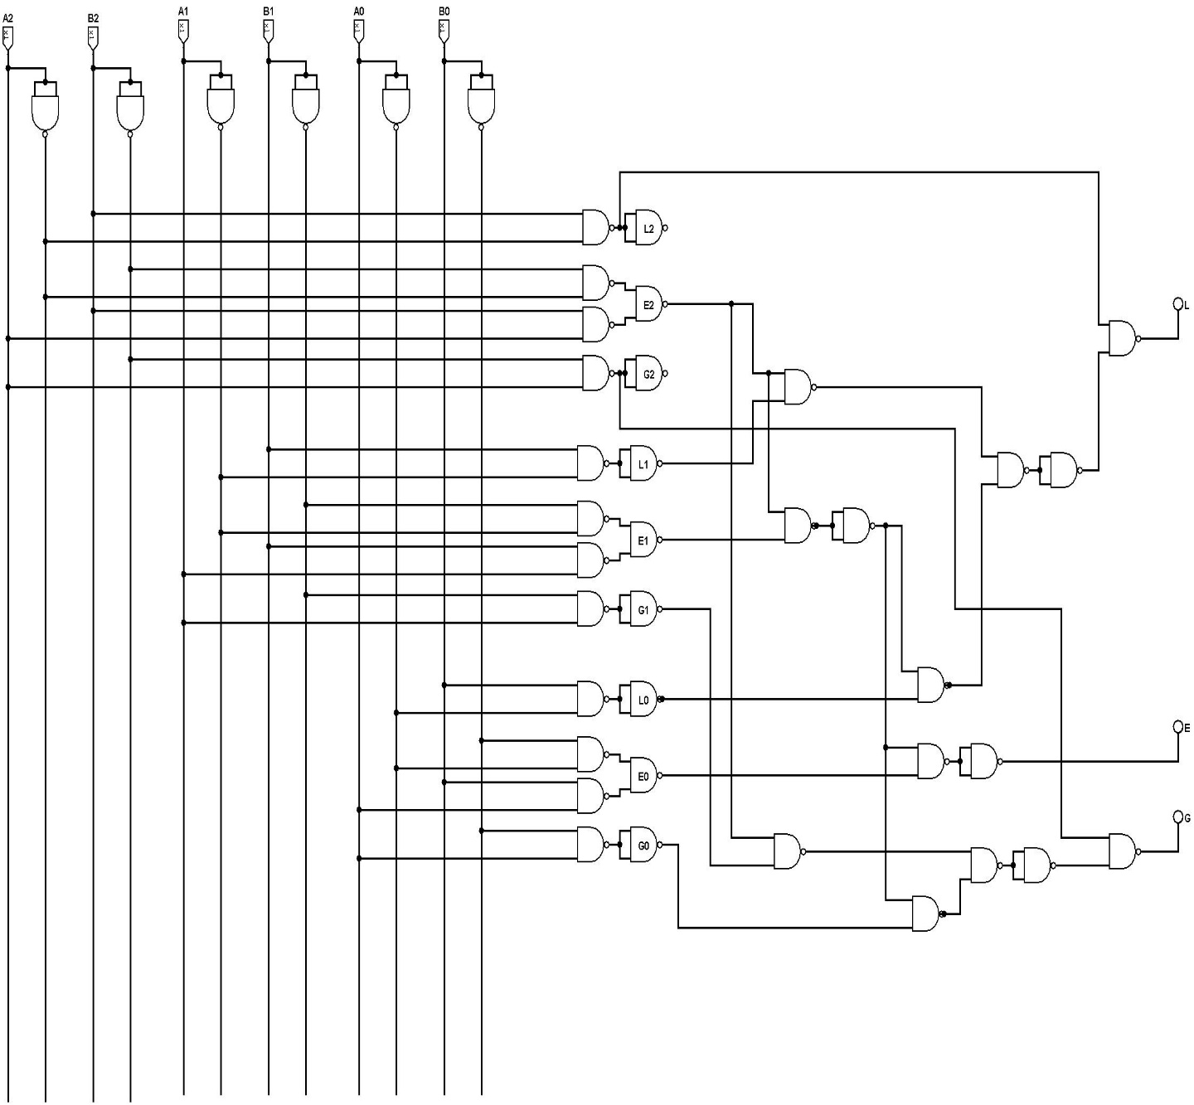**CIRCUIT DIAGRAM:**